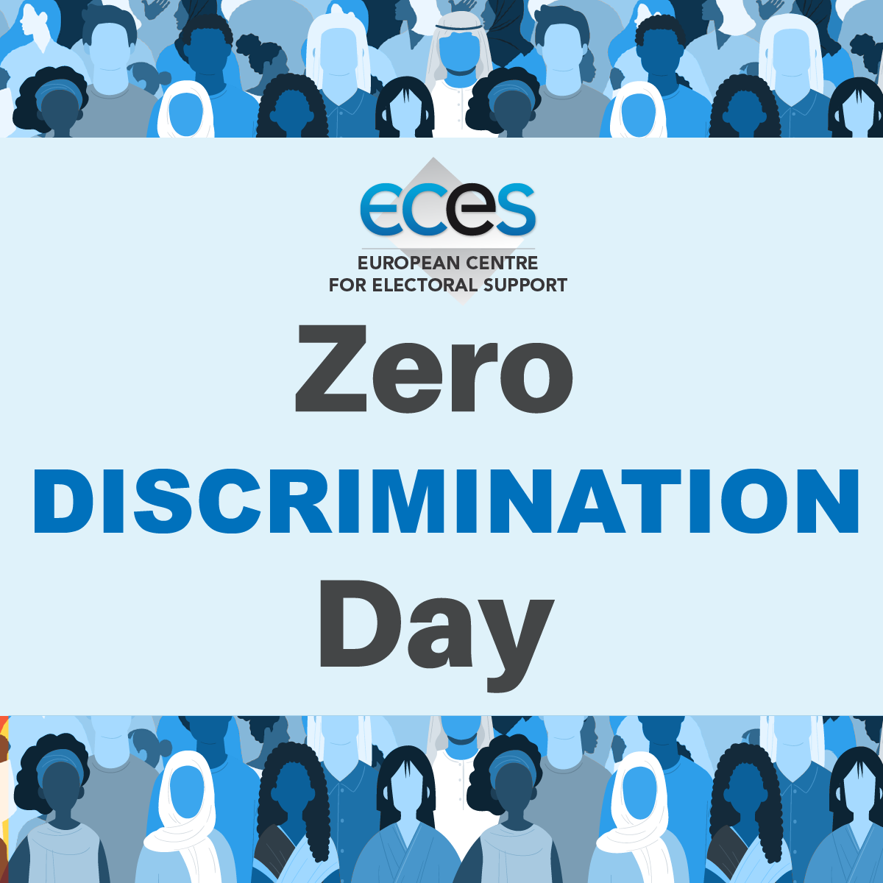 By Sachin Tiwari

**ZERO DISCRIMINATION DAY**



1.INTRODUCTION

Zero Discrimination Day is marked every year on March 1 by the United Nation (UN) and other international organisations. This day is observed by all the UN member countries and it aims to promote equality before the law. Executive Director of UNAIDS Michel Sidibé launched Zero Discrimination Day in the major event held in Beijing and it was first celebrated on March 1, 2014.

March 1 is a day dedicated to ending all kinds of discrimination whether it is social or political hurricanes of hate, borders, barriers and fences. For a flourishing humanity, it is pivotal to avoid all sorts of discrimination.

2. Zero Discrimination Day 2024 Theme

Zero Discrimination Day plays a key role in promoting inclusion, equality, and tolerance across the globe. Discrimination impacts individuals deeply as it creates barriers to accessing education, healthcare, and job opportunities, which eventually leads to poverty and inequality.

As per UNAIDS, criminalisation derives from discrimination and structural inequalities. It robs people of the prospect of healthy and fulfilling lives holding back the end of AIDS and should work in the direction to end criminalisation to save lives.

According to UNAIDS, around 134 nations have criminalised or prosecuted HIV non-disclosure, exposure, or transmission, while 20 nations have criminalised or prosecuted transgender people. Not only this, 153 nations, criminalise at least one aspect of sex work and 66 have criminalised consensual same-sex sexual activities.

